Security Testing for : www.vitalitycares.online

This report gives a detailed analysis of results that was obtained upon various security testing that was carried out on the finished website listed above.

URL MANIPULATION: after logging into the admin page, I copied the URL of the logged in page and then logged out. After that i pasted the copied URL back into the browser to see if it took me back to the dashboard but I was taken back to the index page which shows that everything was fine.
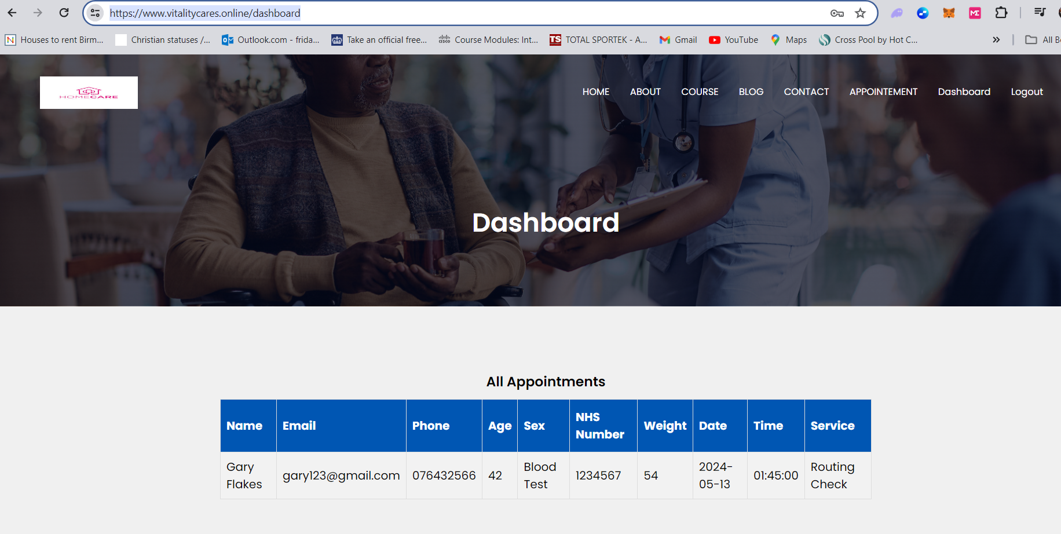

Cookies Based testing: upon running a basic scan of the URL with a certified Pentest Tools. I found that a cookie has been set without the HttpOnly flag, which means it can be accessed by potentially malicious JavaScript code running inside the web page. This is normally caused by misconfiguration in the code.
Risk: the risk is that an attacker who injects malicious JavaScript code on the ( e.g. by using an XXS attack ) can easily access the cookie and send it to another site. In the case of a session cookie, such that are used by large organizations like banks, this could lead to session hijacking.

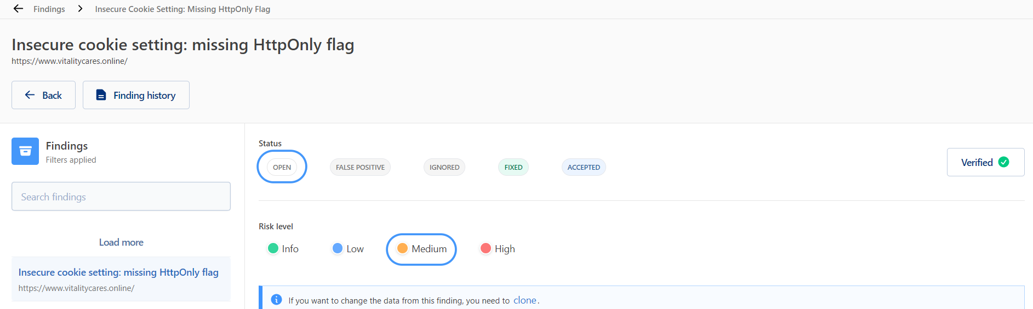

SQL injection: I performed an SQL injection on the input field and was met the screenshot below which shows there are measures of prevention from an attacker and the allowed inputs must match the requirements.
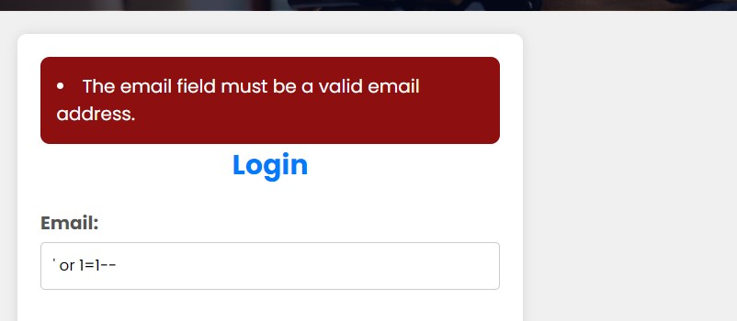


Result-


Man in the Middle Attacks: I conducted a Man in The middle attack, however there appears to be no data to tamper with

Packet Intercepted-
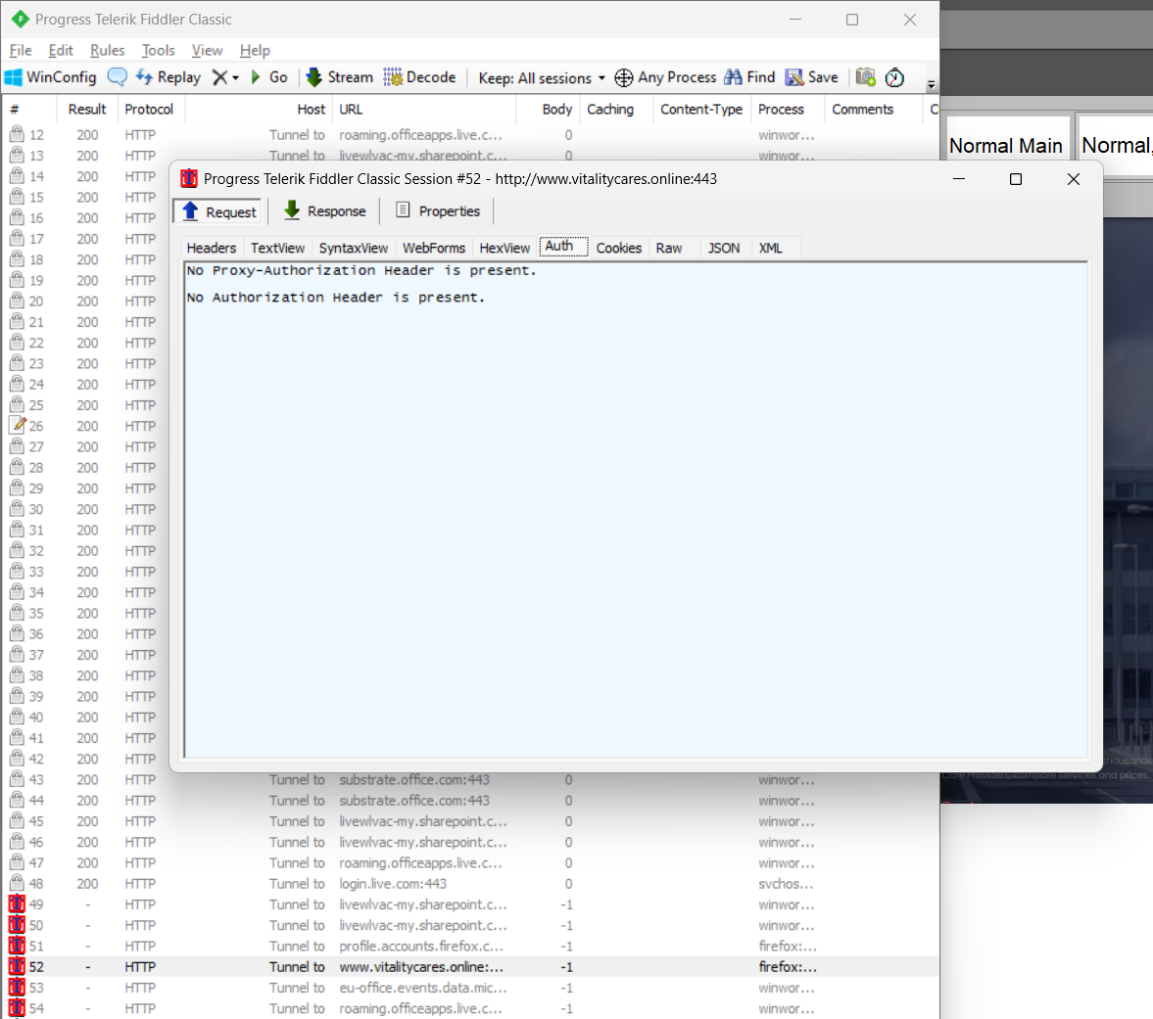
However, no data to tamper with

Attempted Login(know credentials): I registered as an admin and logged in to see the information of clients that booked appointments. Upon inspecting the elements of the page, I found no vulnerability.

Element Inspection : I logged into the admin page where the appointments details of the clients are and whilst logged in, I carried out an element inspect and found no obvious vulnerability.
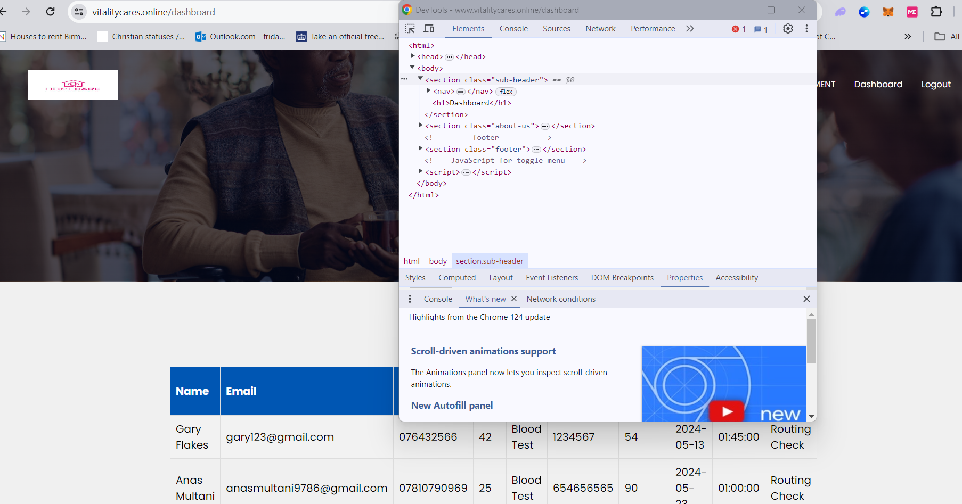

Conclusion:
Finally, the web application's security test revealed a major vulnerability caused by the lack of the HttpOnly setting in cookies. This vulnerability opens the application up to possible attacks including cross-site scripting (XSS), in which malicious scripts can access cookies and compromise user data.
Addressing this issue is critical for maintaining the security and integrity of user information. Implementing the HttpOnly option in cookies makes them unavailable to client-side scripts, lowering the danger of XSS attacks and unauthorized access to sensitive information.
solution:
It is suggested that you take immediate action to address this issue by activating the HttpOnly setting for all cookies used in the application. Furthermore, continuous security procedures should be built to proactively detect and resolve possible vulnerabilities, ensuring the continued protection of the web application and its users' data.

